**User Group Q&A**

***Updates from eClinicalWorks 11.52 Upgrade***

**Question 1: We used to be able to change the patient’s pharmacy from the prescribing screen and make this the primary pharmacy. Now we must change it manually for each medication.**

Encourage the staff to update the pharmacies at registration under *Patient's info > Pharmacies > Add*, then select from those pharmacies while prescribing. If not added at registration, and directly selecting from the *Common Send* window, the prescriber will need to select a *pharmacy* for the individual prescription.

**Question 2: If we go to the pharmacy screen without selecting a pharmacy and hitting prescribe, it will print the prescription instead of sending it electronically. We have the same problem for controlled substances, which affects patient safety.**

After the upgrade, the primary pharmacy does not automatically populate for the prescription window. Now the pharmacies are preloaded on the drop-down list. The prescriber must select the prescriptions, select *pharmacy* from the drop-down list, and click on *Apply to Selected* to proceed with the prescription. Encourage the staff to update the pharmacies at registration.

Once prescriptions are sent, they are locked and cannot be resent. However, a copy of the locked prescription can be printed by selecting Eprescription log in the hub. *Note: This is only a copy and is not a valid prescription.* To get a valid prescription the user must create a telephone encounter and create a new prescription.

**Question 3: Why do the parent‘s email and pharmacy not copy for siblings when linked to same guarantor?  Only the address, phone number, and insurance copy to siblings when linked.**

There is not an option available as of now to copy over the email and pharmacy details for siblings. If you would like to suggest this option for a further enhancement, please visit our website and share in eClinicalWorks ideas

**Question 4: Can you explain why there is a Common Send Window?**

All the patient orders/medications from the Encounter are listed to transmit/print. It displays all the orders and medications for the patient on the encounter.

See screenshots below for more information.

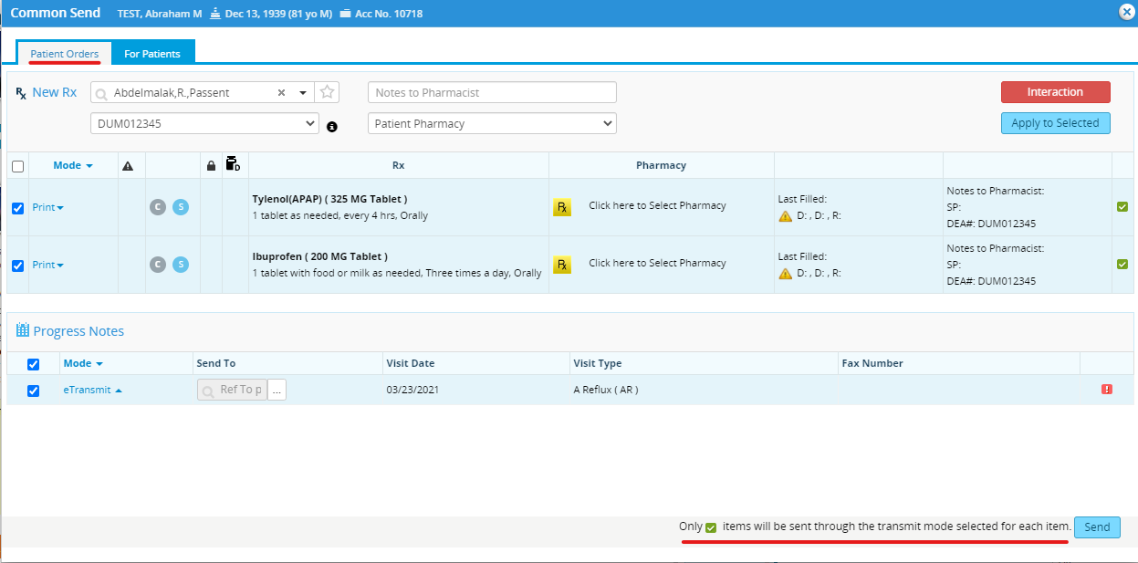

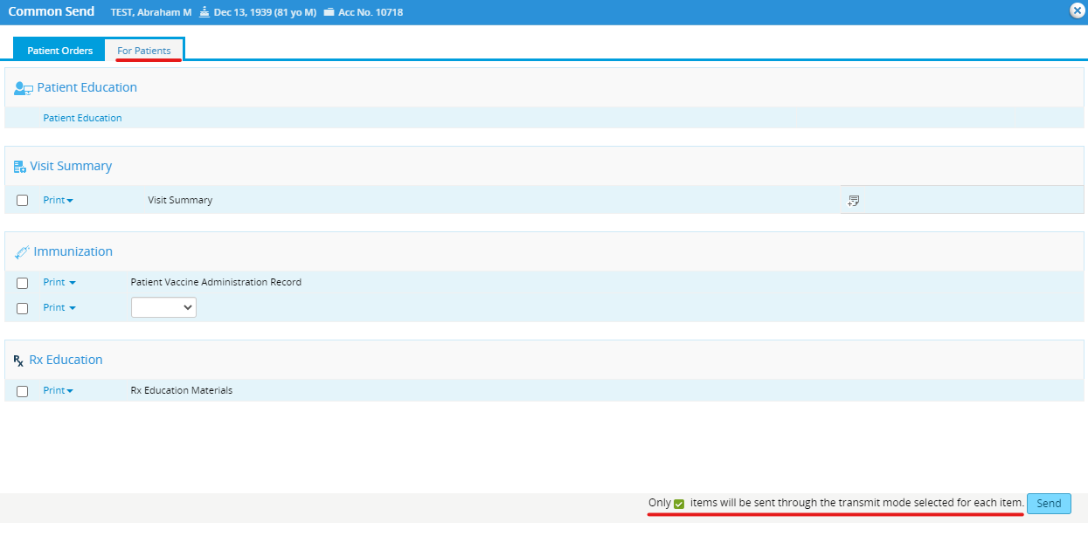

**Question 5: How do you change a future appointment if the progress notes and medications have already been pulled over?**

Update the setting to allow users to change Date/Time of appointments:

>>File  
>>Settings  
>>Practice Default  
>> Options Tab  
>> Enable changes to the Date and Time Fields on the Appointment window  
>> Check the option  
>> Click on Save  
>> Log out and log back in (All Employees)

However, if there is data from previous encounters documented, the system will not allow the user to delete. The user can remove the details from the chart and then cancel appointment.

**Question 6: There is significant slowness on Monday mornings, can this be addressed?**

**In order to validate the slowness of the system, please submit a ticket on the eCW support portal. Since there are so many practices that are experiencing this issue, PHNIQ is working with eCW to get some “tips and tricks” to address slowness. If there are any issues with the ticket that is sent in, please flag to us at** [phnservices@childrensnational.org](mailto:phnservices@childrensnational.org)**.**

**eCW Support Portal**

**As a reminder, there are resources for practices available on the** [eCW Support Portal](https://my.eclinicalworks.com/eCRM/portal/login.jsp)**. This portal includes videos that may help with workflow issues.**