<< INSERT PRACTICE LOGO AND/OR HEADER >>

Young Adult (18 Years +) Release & Consent Form

I, ________________________________________, DOB __________________, give <<insert practice name>> permission to discuss the following information about my health with the following individuals: 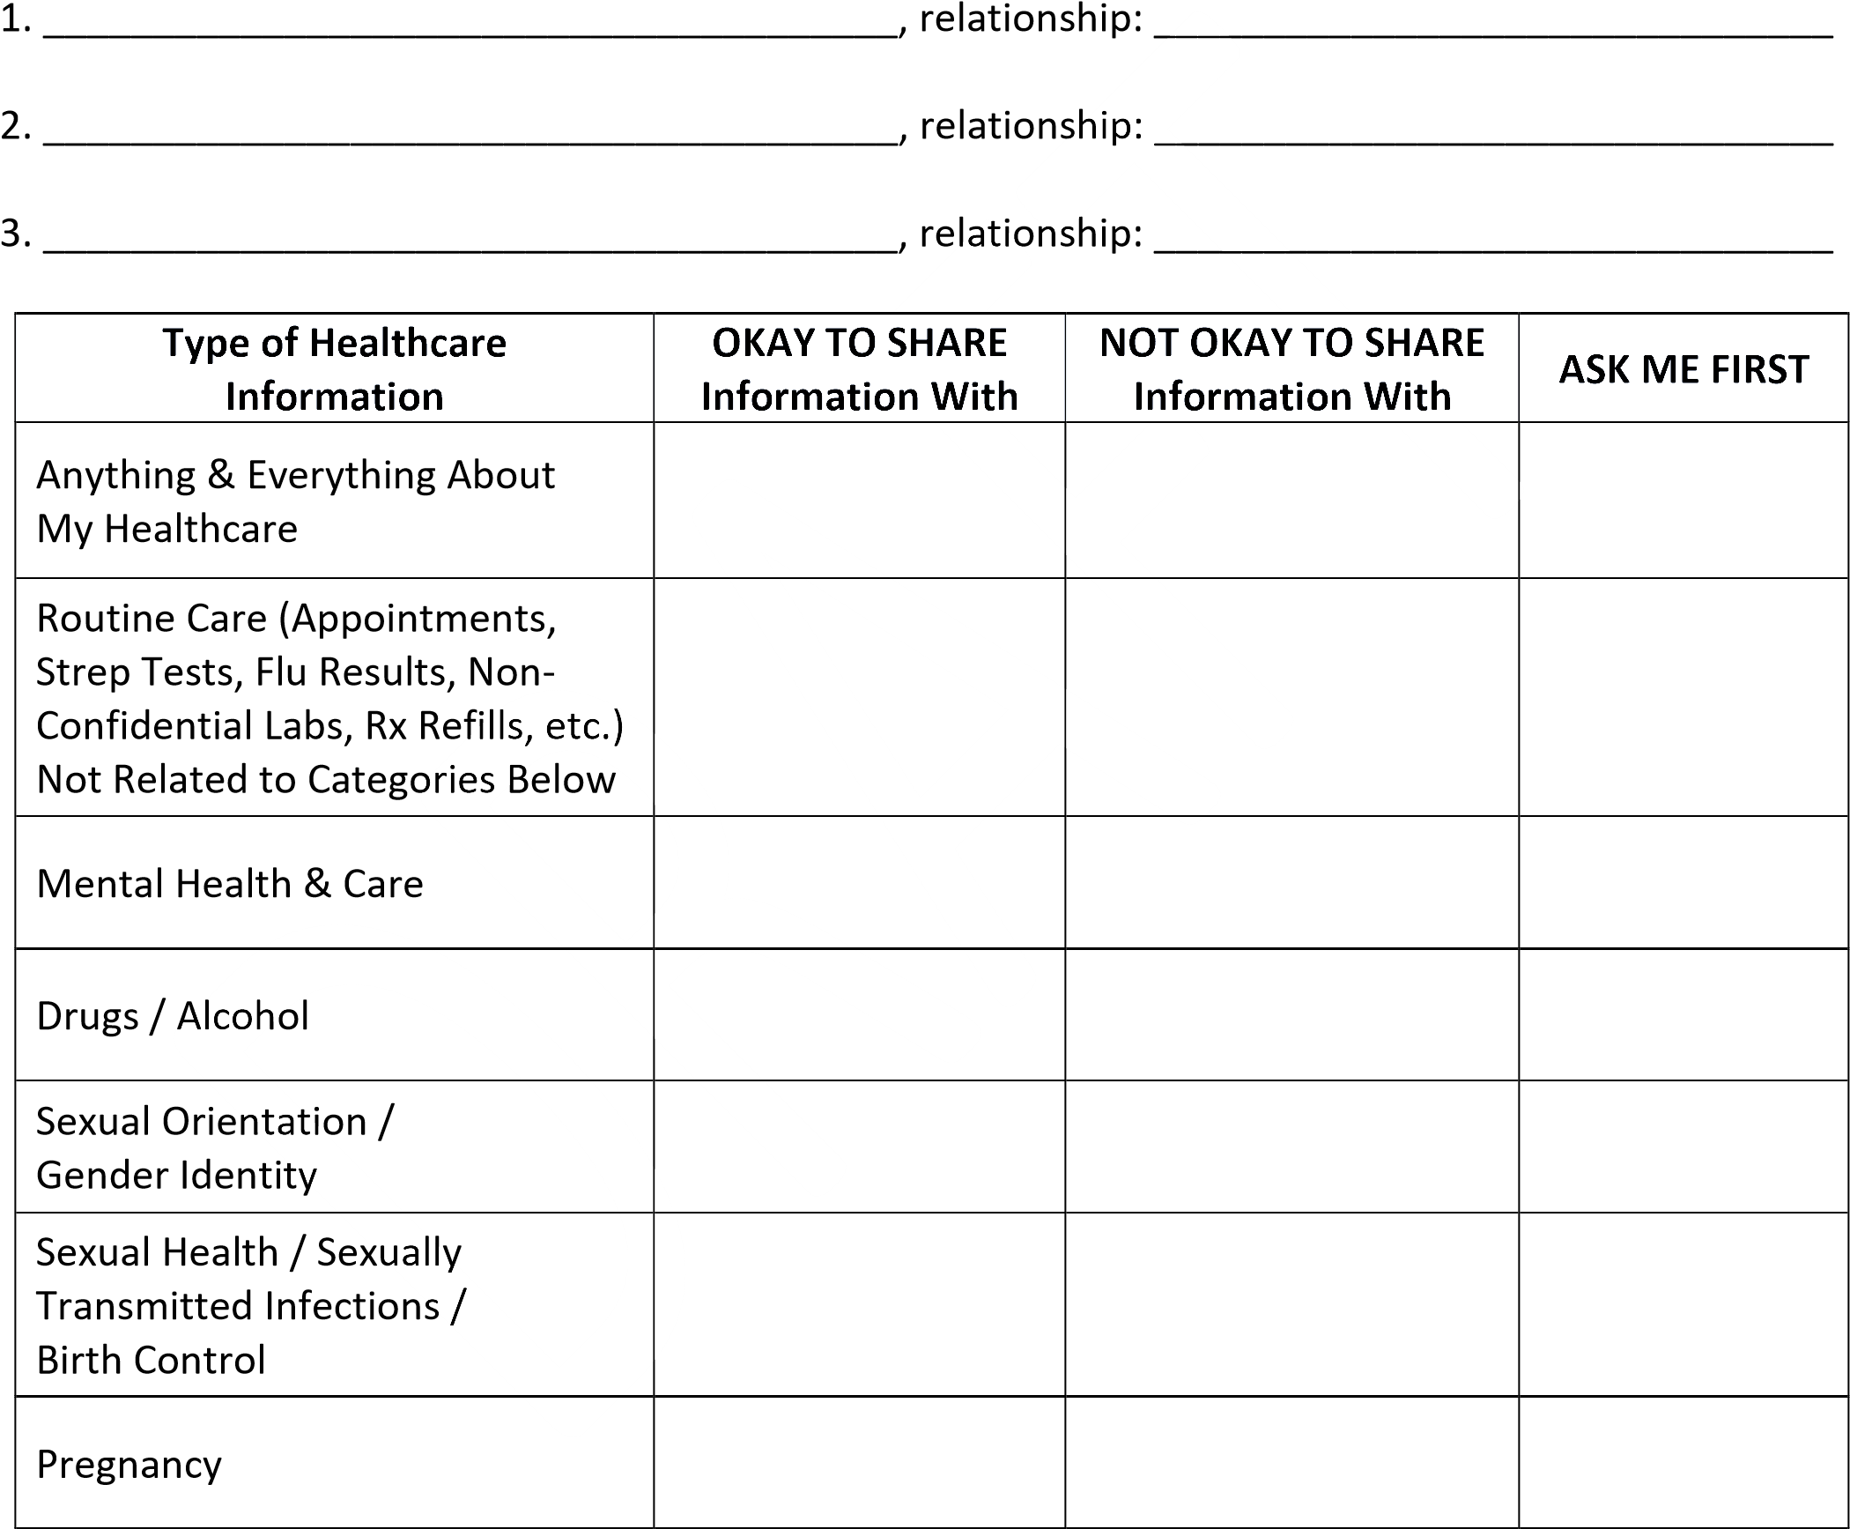

___________________________________ ________________ ______________________________
Patient Signature Date Patient Phone #

___________________________________ ________________ ______________________________
<<insert practice name>> Witness Date Patient Email Address

